Assignment 6.4

Name : M.Varsha

Roll.no : 2403A51311

Batch : 13

# Task 1 :

Start a Python class named Student with attributes name, roll_number, and marks. Prompt  
GitHub Copilot to complete methods for displaying details and checking if marks are above  
average.

# Prompt :

generate a Python class named Student with attributes name, roll_number, and marks, plus methods like display_details() and is_passed() (checking if marks are above average) with examples.

# Code and Output :

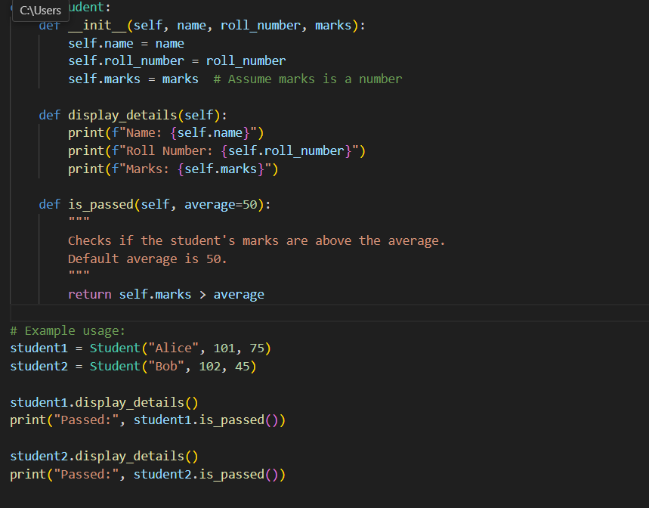

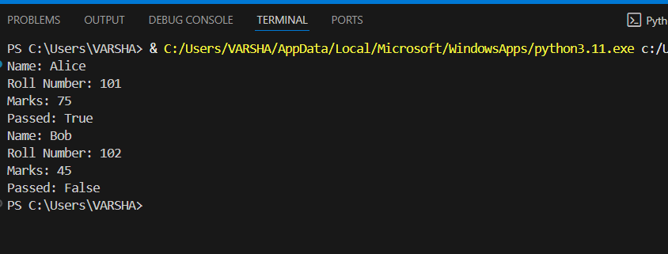

# Task 2 :

Write the first two lines of a for loop to iterate through a list of numbers. Use a comment  
prompt to let Copilot suggest how to calculate and print the square of even numbers only

# Prompt :

write a loop that iterates through a list of numbers and **calculates and prints the square** .

# Code and Output :

# Task 3 :

Create a class called BankAccount with attributes account_holder and balance. Use Copilot to  
complete methods for deposit(), withdraw(), and check for insufficient balance.

# Prompt :

Write a python function to generate a BankAccount class—complete with deposit(), withdraw(), and insufficient balance using if conditions with examples

# Code and Output :

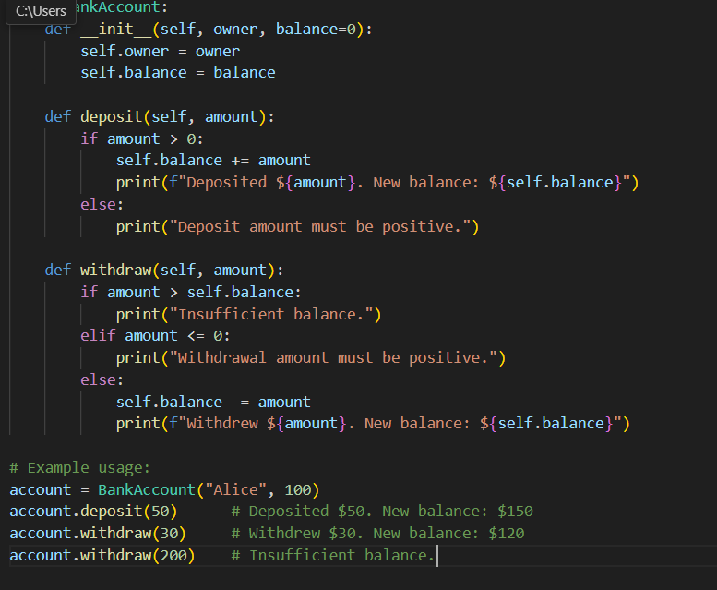

# Task 4 :

Define a list of student dictionaries with keys name and score. Ask Copilot to write a while  
loop to print the names of students who scored more than 75

# Prompt :

Defines a list of student dictionaries with keys name and score.write a while loop that prints the names of students who scored more than 75.Generates a complete while loop with proper condition checks and nicely formatted output.

# Code and Output :

# Task 5 :

Begin writing a class ShoppingCart with an empty items list. Prompt Copilot to generate  
methods to add_item, remove_item, and use a loop to calculate the total bill using conditional discounts

# Prompt :

write a python function to generate a ShoppingCart class—including methods to add and remove items, as well as a loop that computes the total with conditional discounts:

# Code and Output :



 